(Part 3)

310 Center

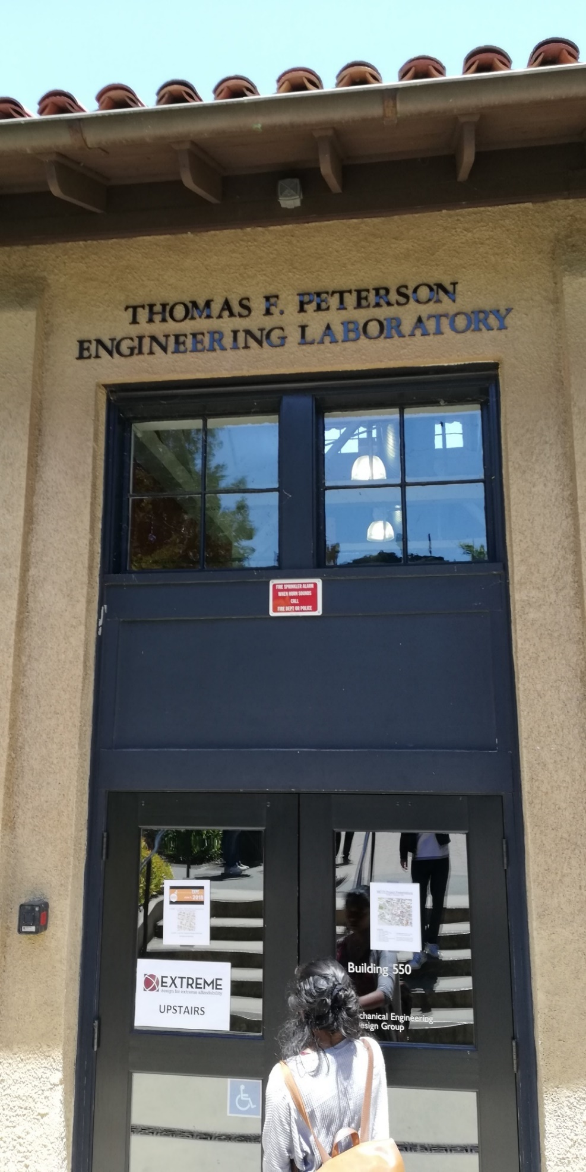

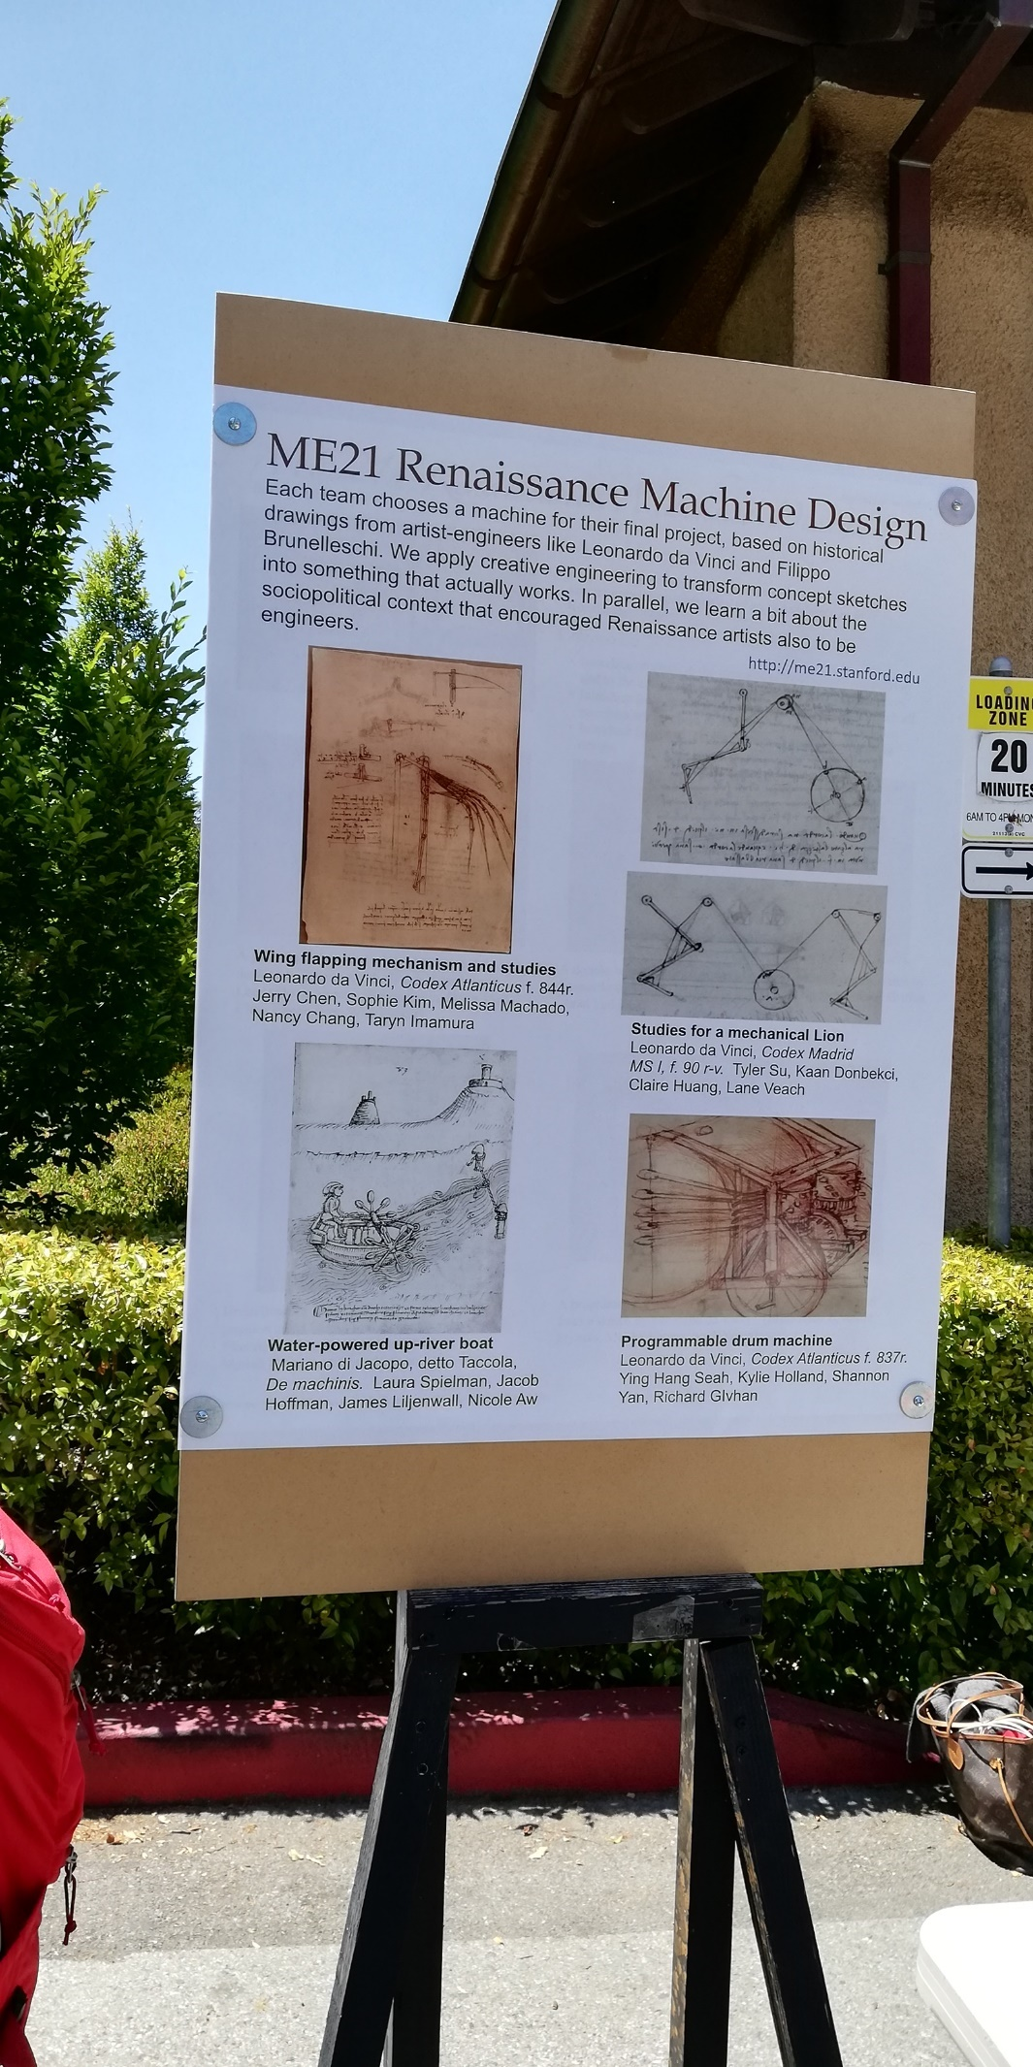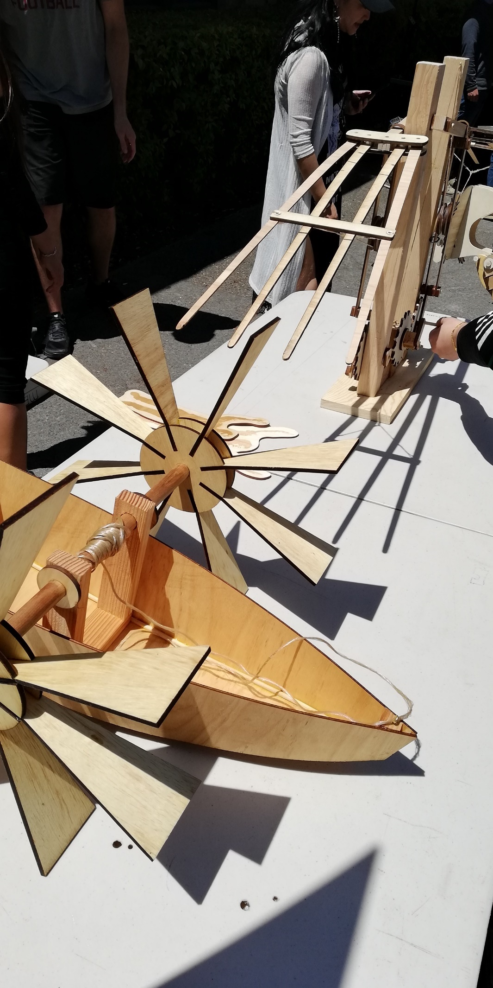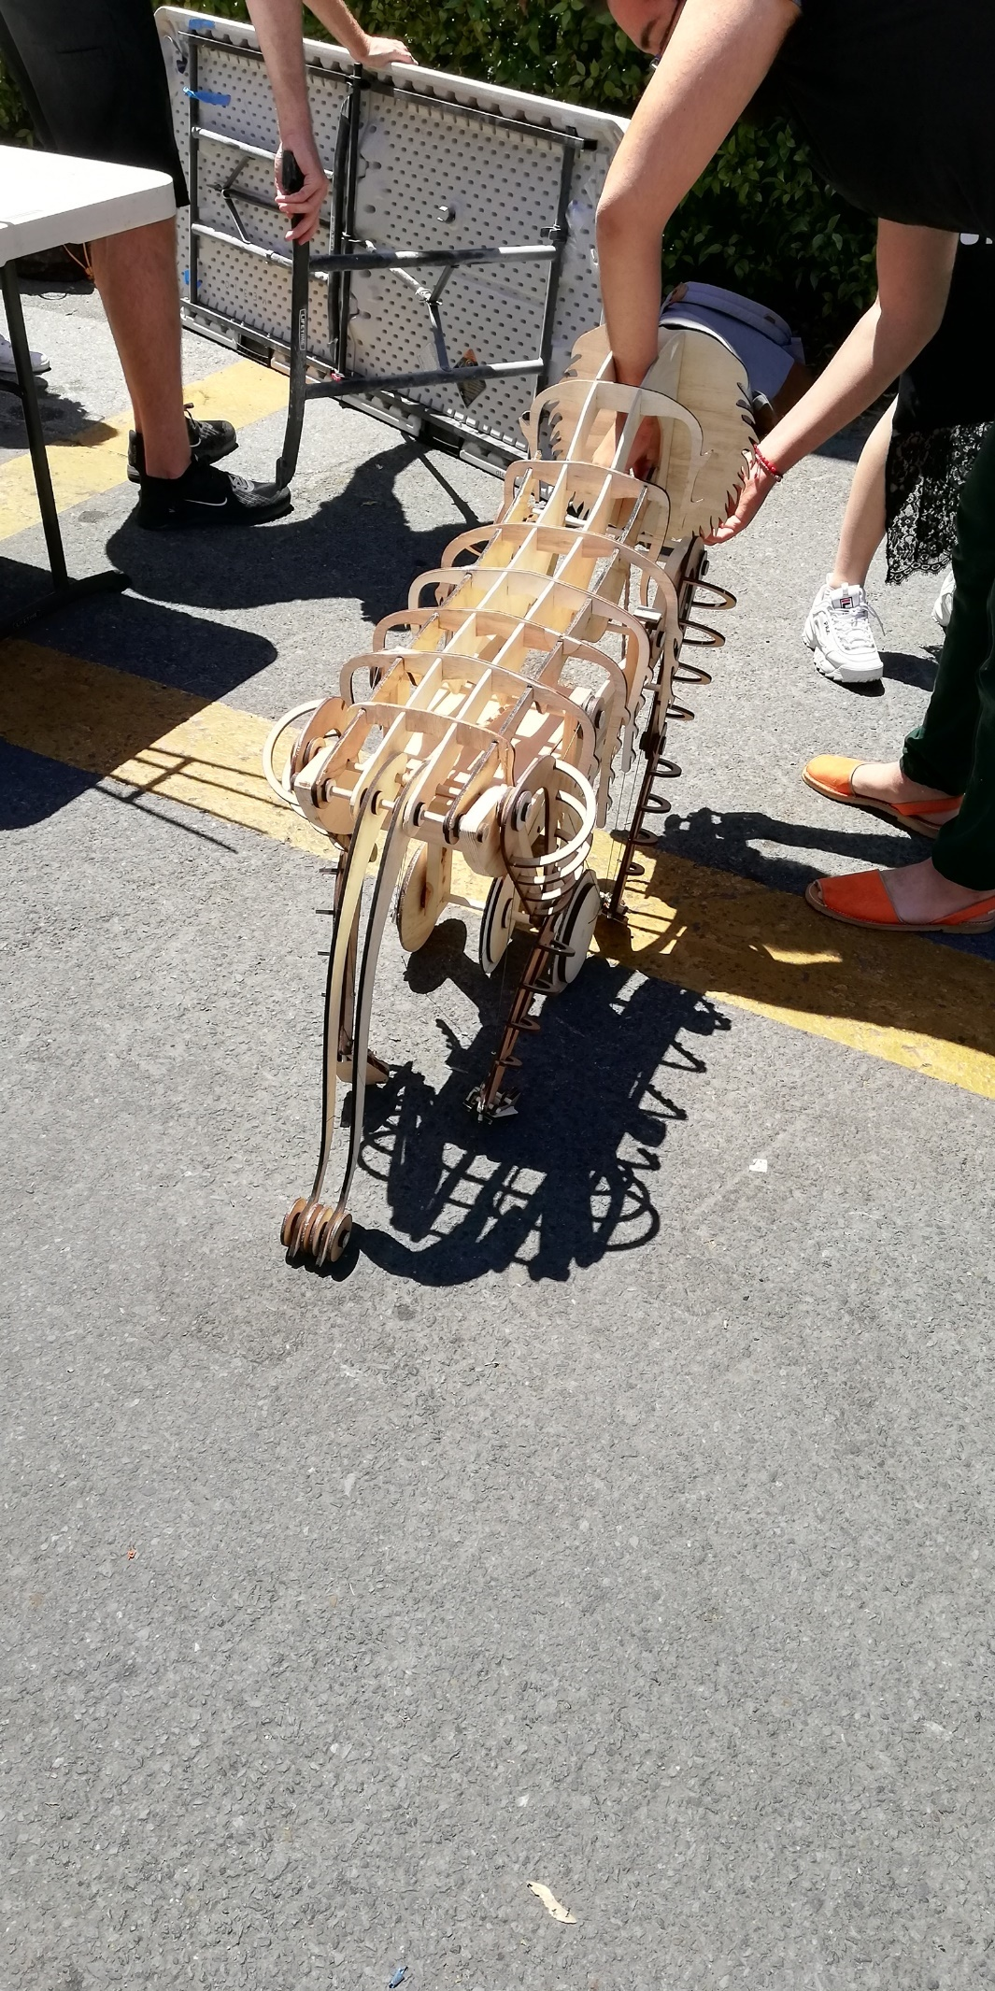

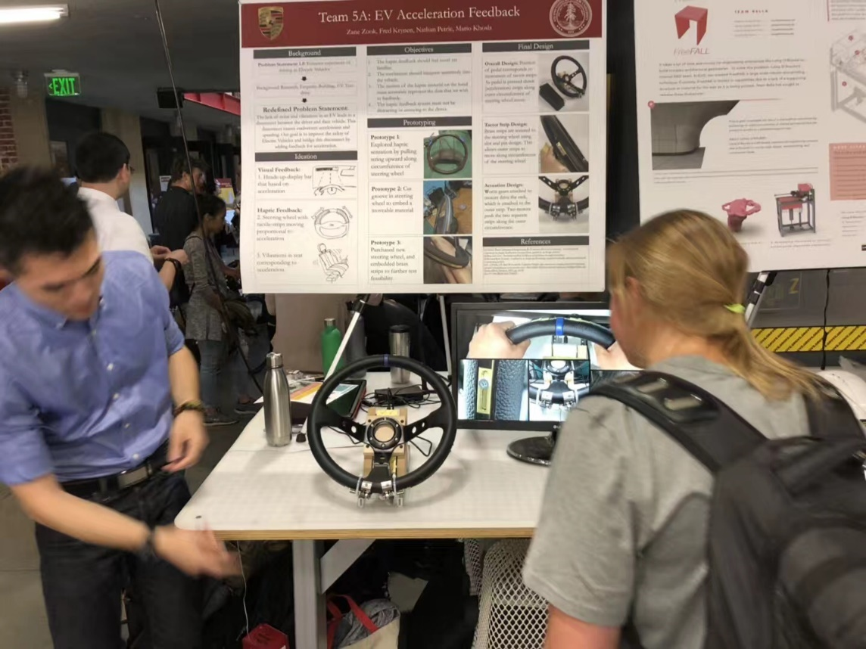



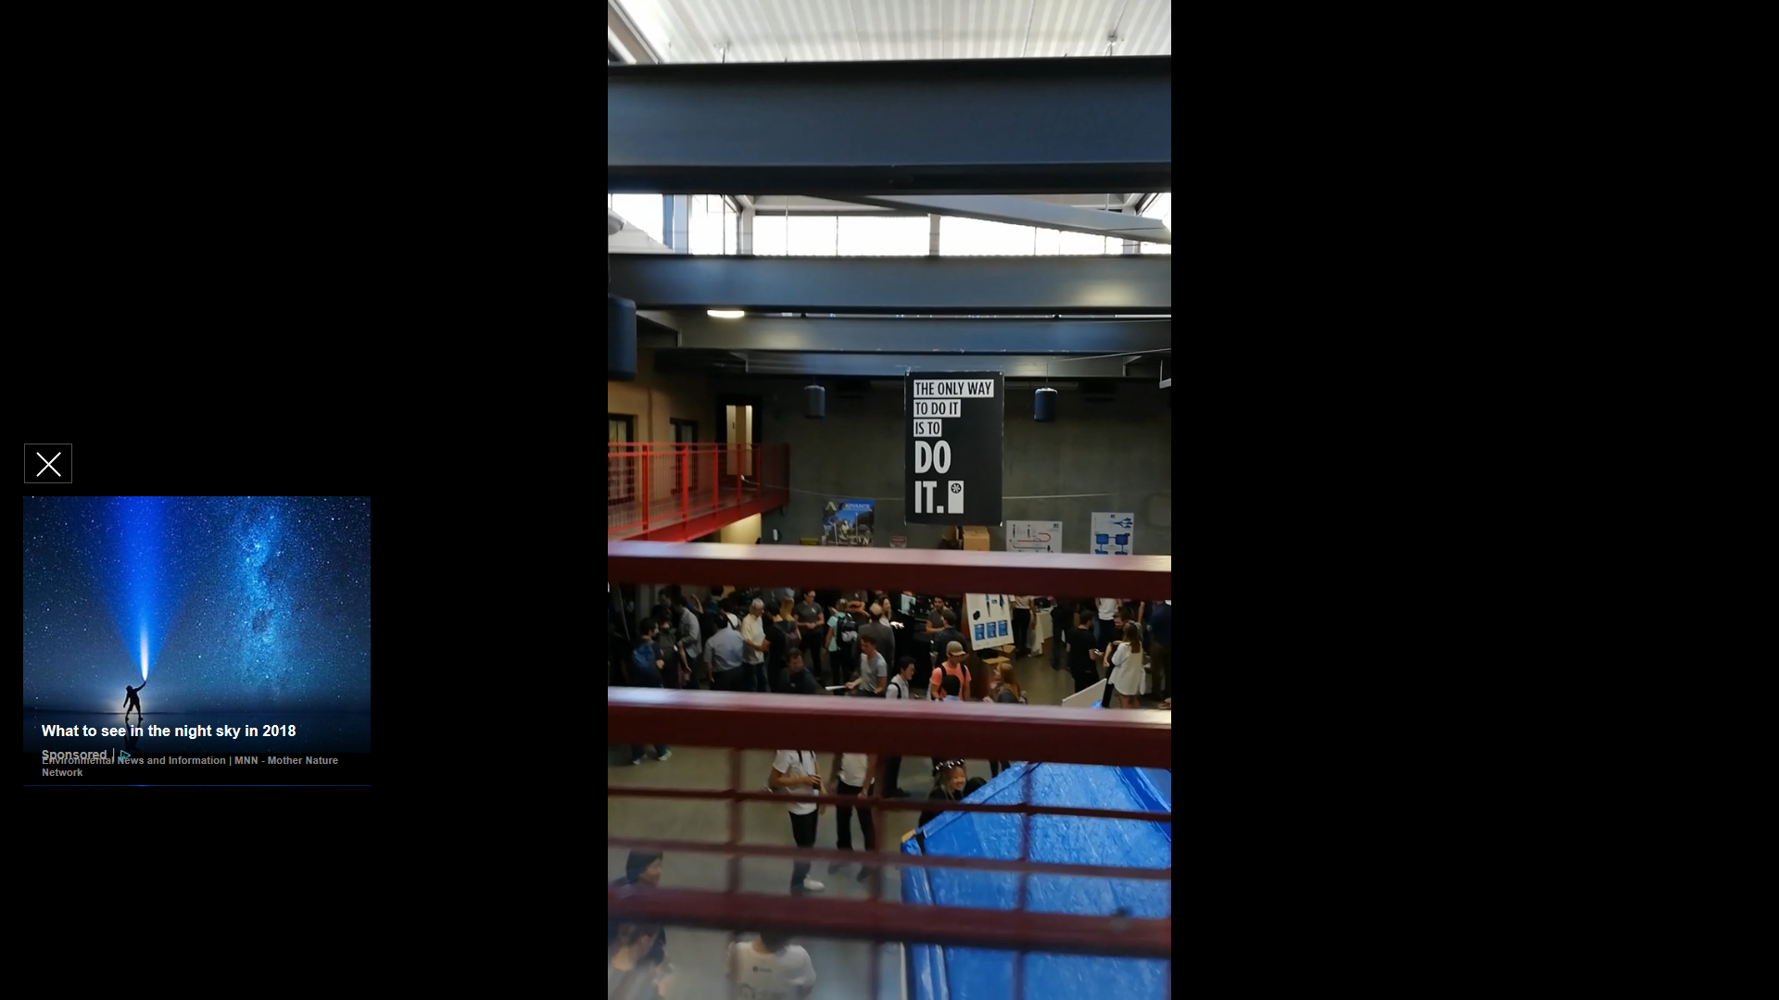

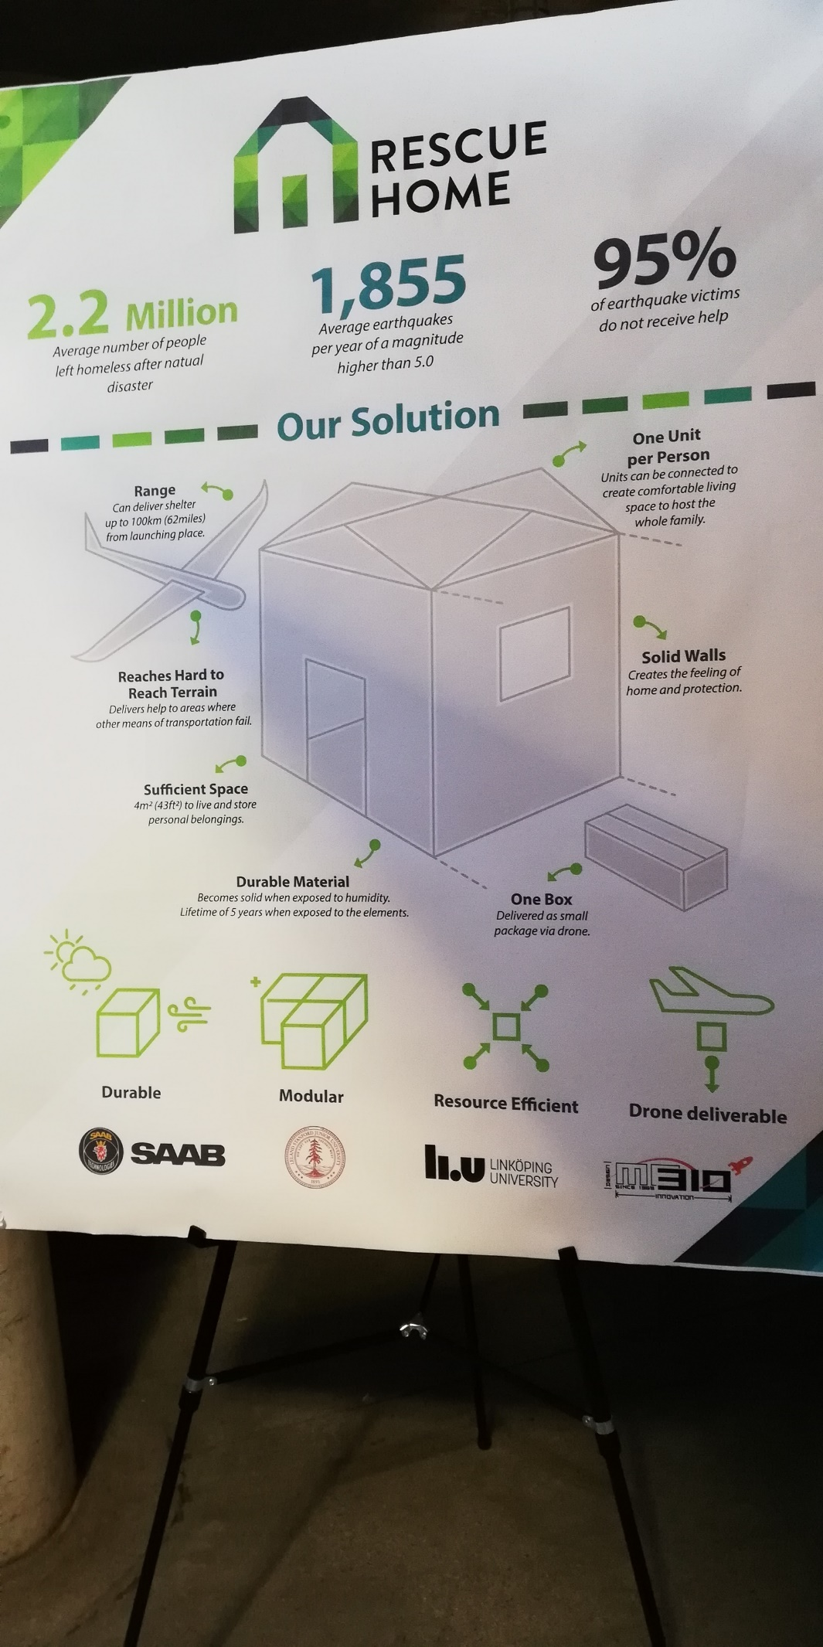

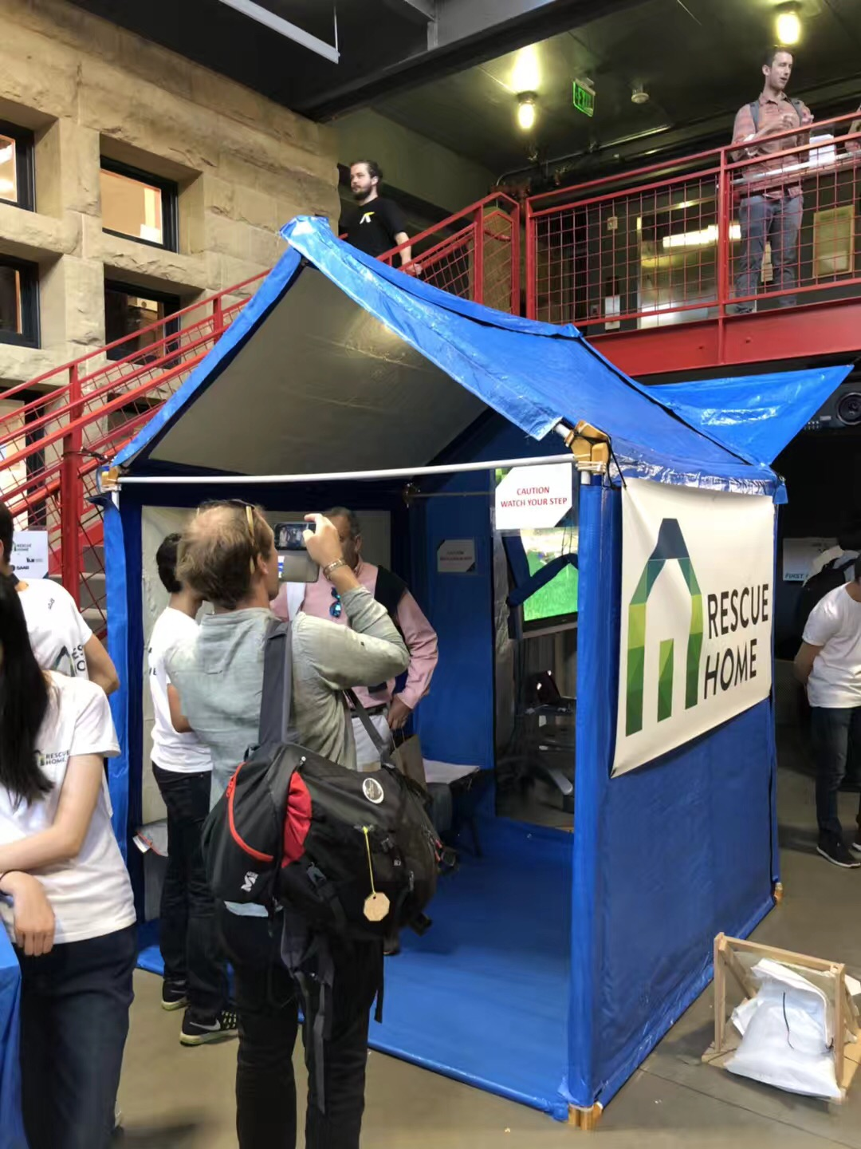

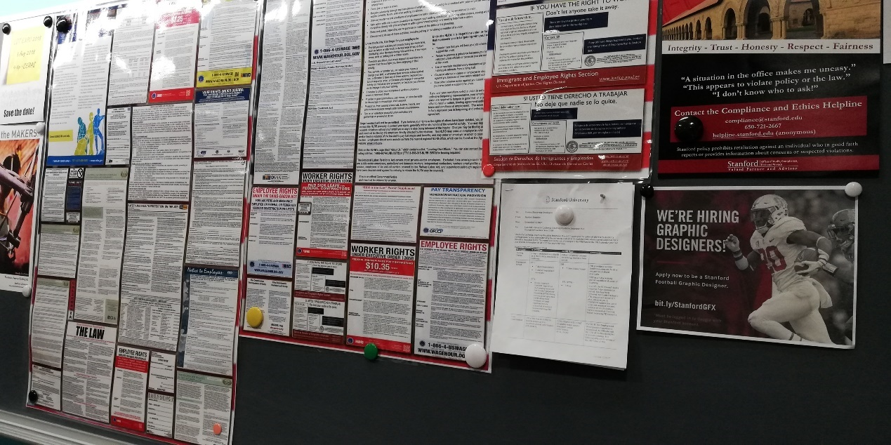

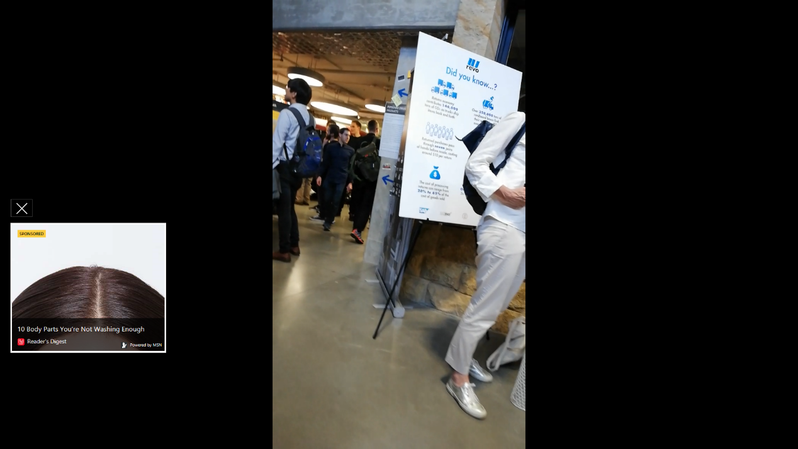 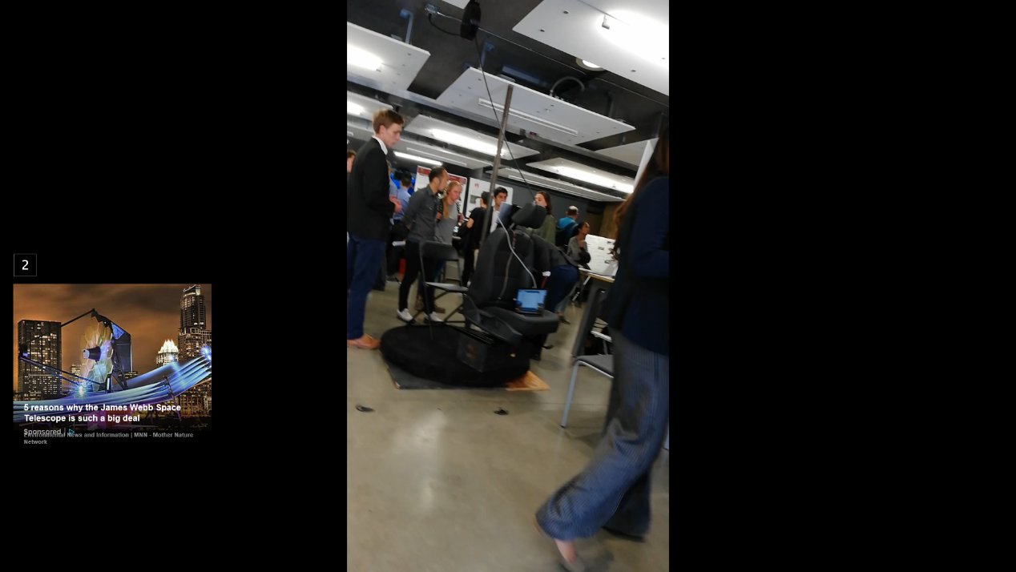 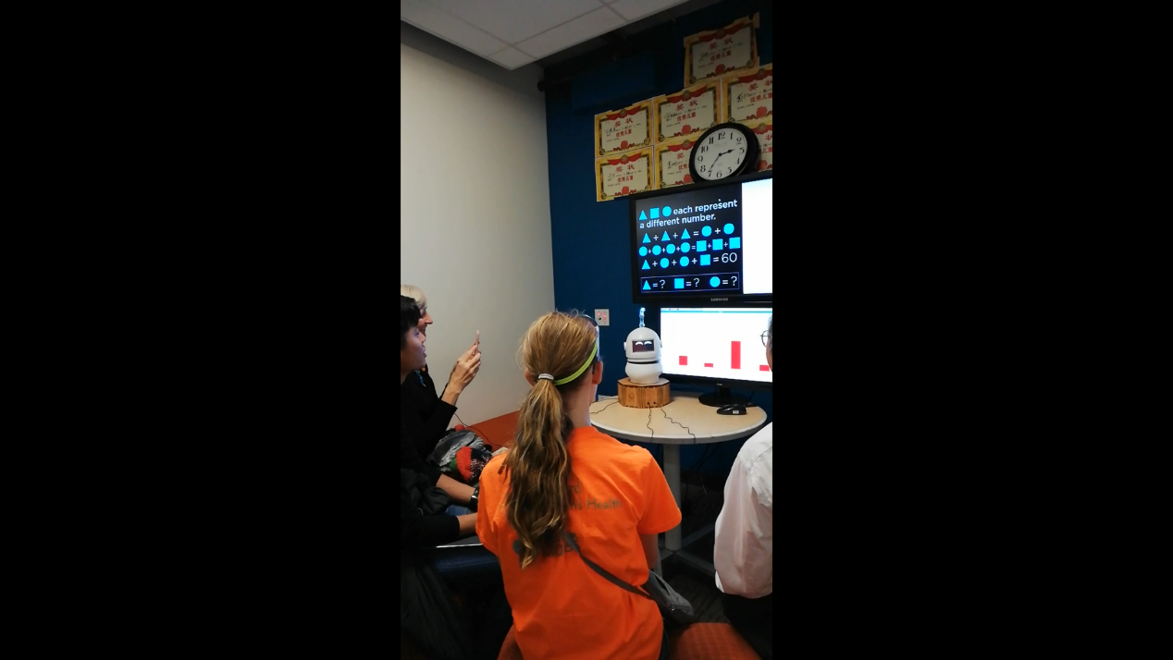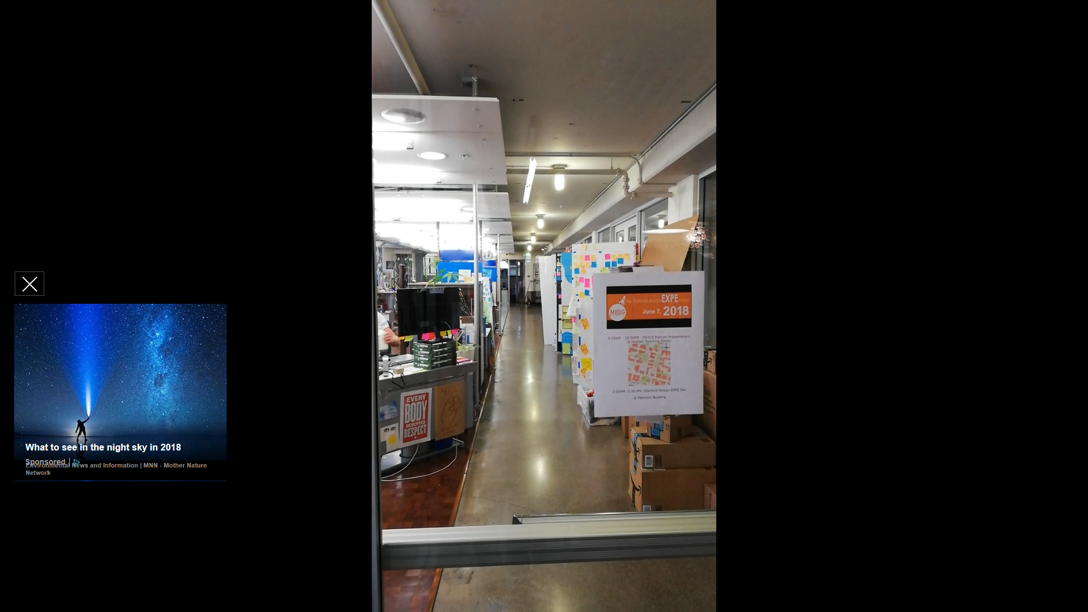 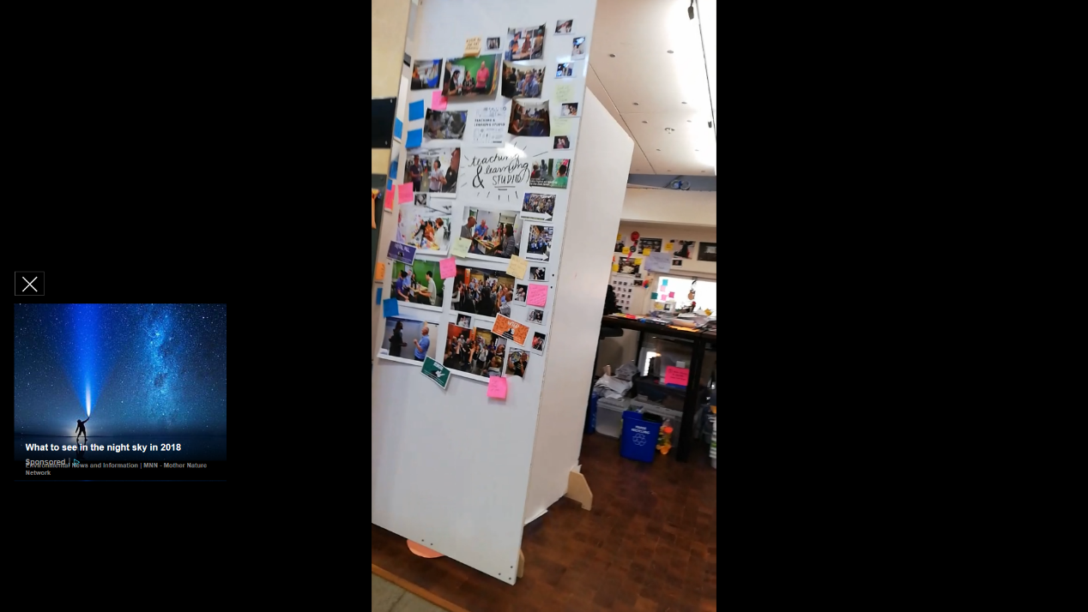 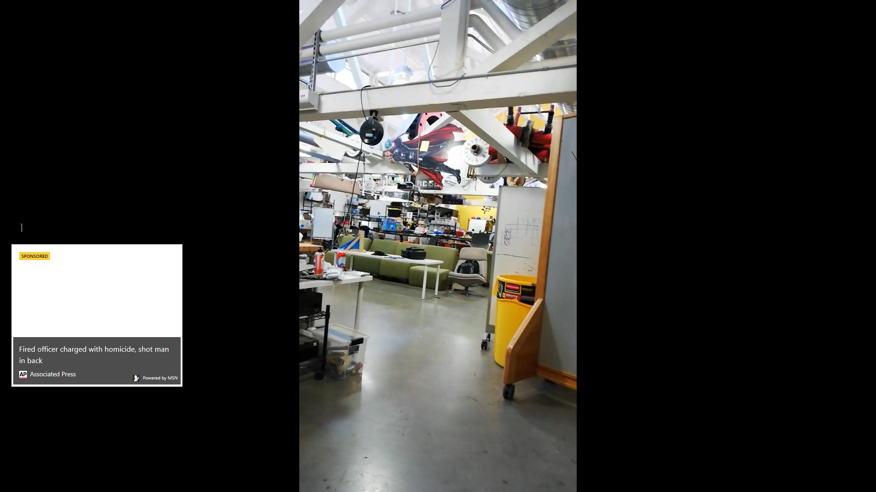 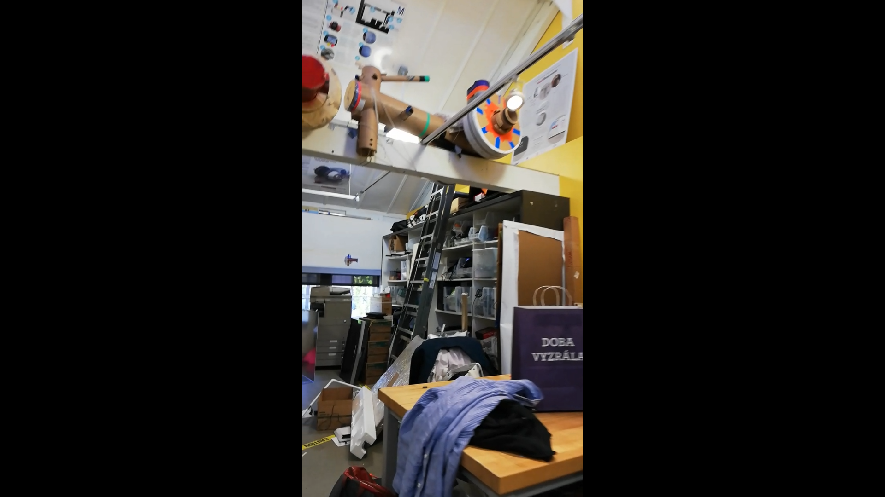

Student’s workshop

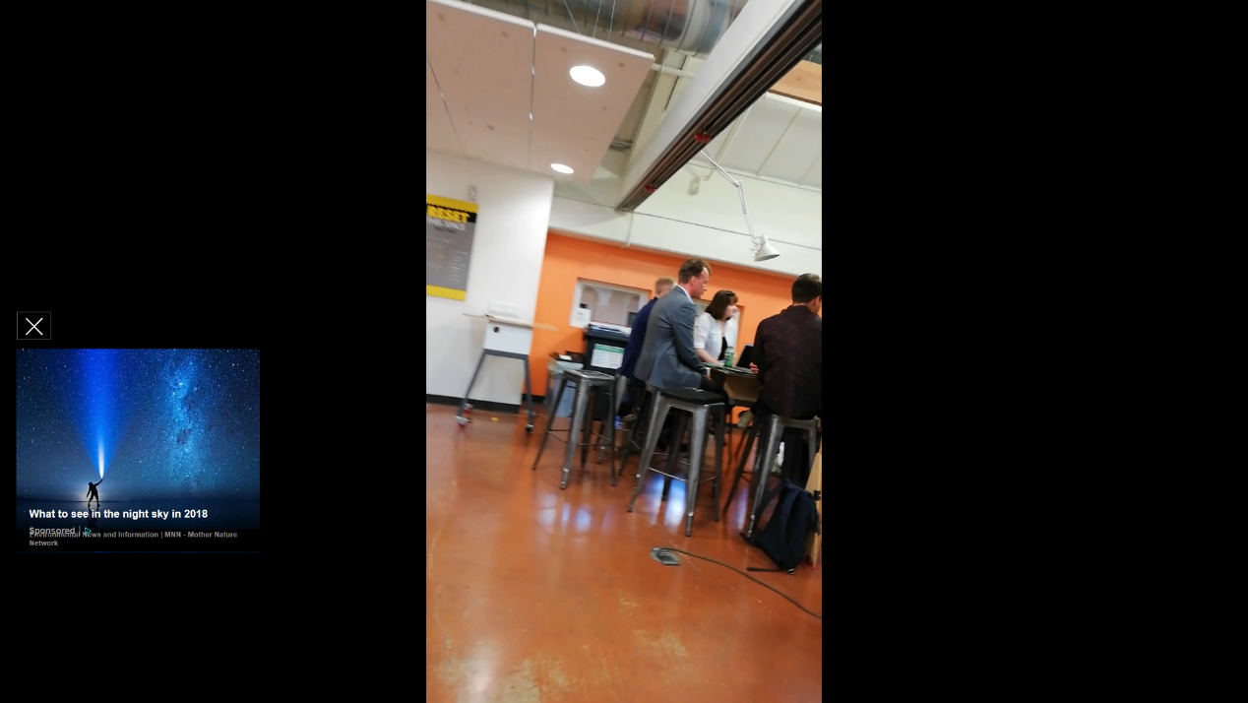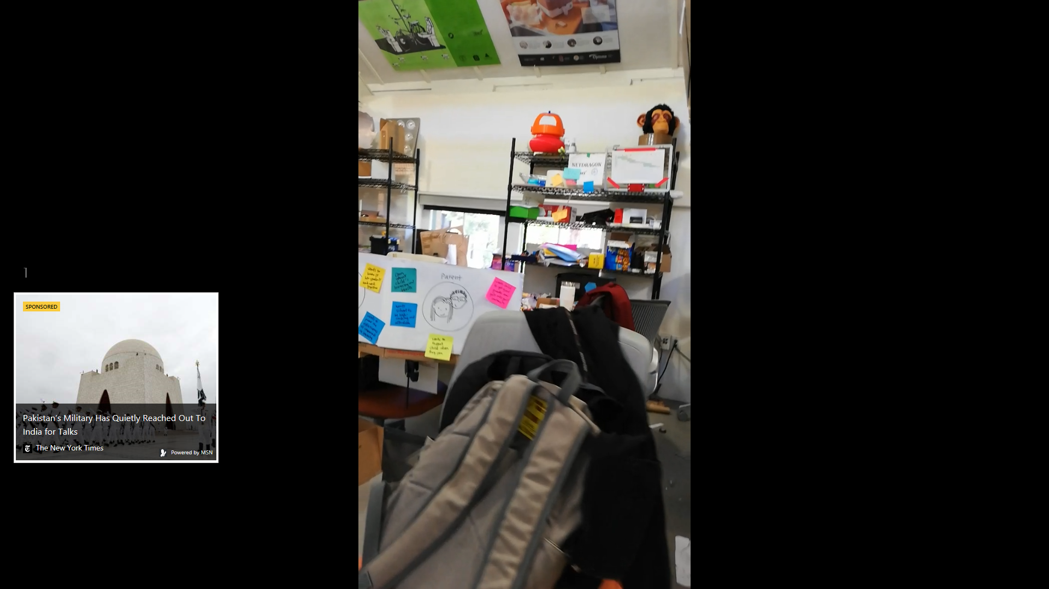

Time flies when you’re having fun, and it was time to go back to the classroom.

“From this experience, you may have noticed the sign hung in the middle of the lobby saying ‘The only way to do it is to DO IT.” Ms. Carleton said.



“One of the key concepts of this class is getting your hands dirty. This means getting physical, getting tangible, so all students learn this belief and more importantly they take this belief into the work that they do after they graduate.” “So, why do you prototype? Well, because you learn about the opportunity and the user when you build something. Another key point is to start conversation. It is often hard for people to imagine what’s in your head, but if you can show a physical object, they’d react in the way like ‘oh! That’s what you meant!’ With that being said, prototyping is a great way to help you bring your concept to life. Now this is a big belief in Silicon Valley: you prototype to learn fast, every opportunity or failure is a chance to learn something. Every time you prototype, you’re exploring another design angle, another question. So, I’d like to introduce you several different methods for prototyping.”

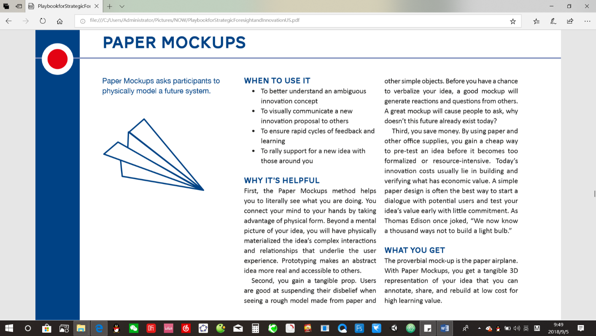

Pictures from *Playbook for Strategic Foresight and Innovation US*

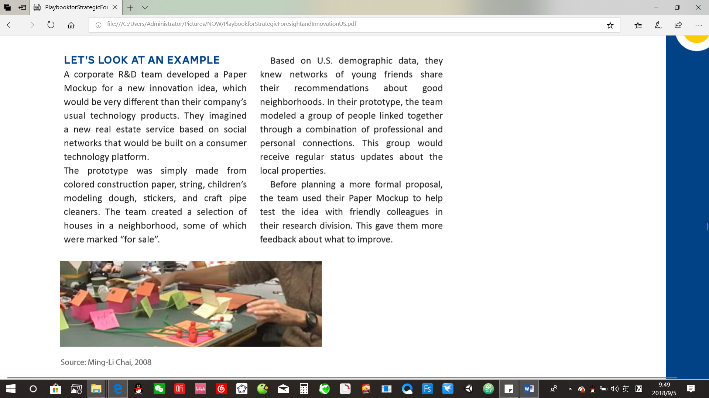

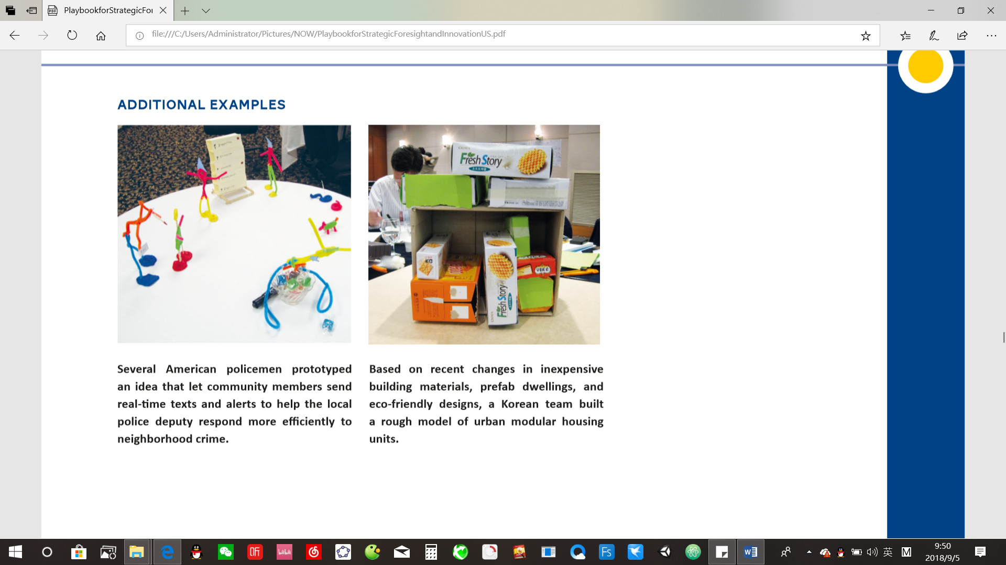

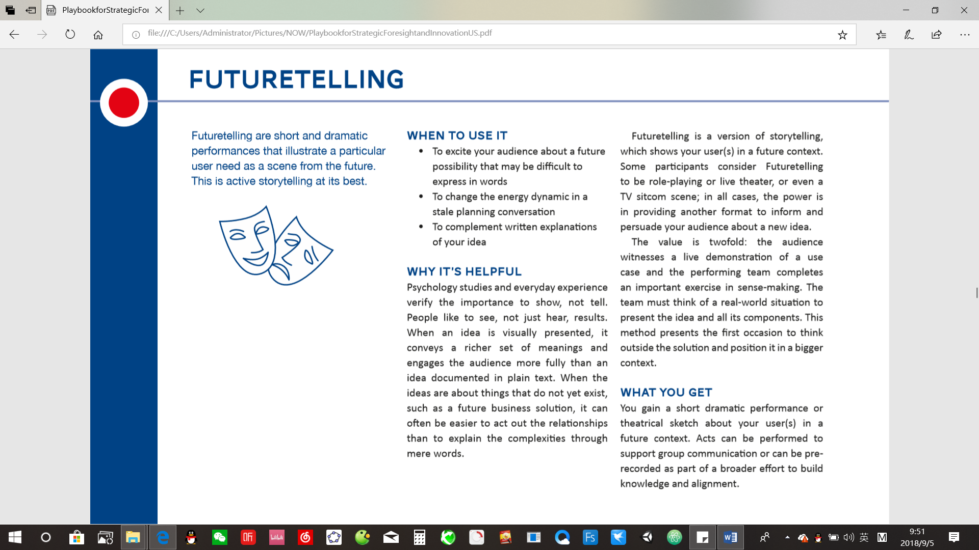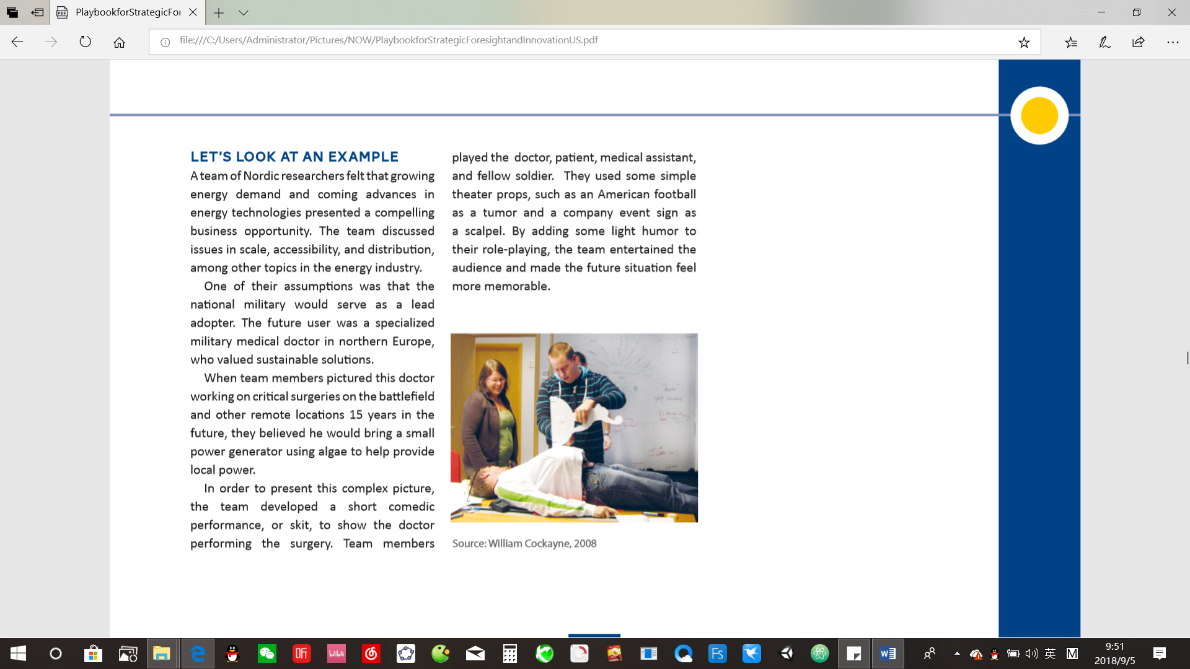

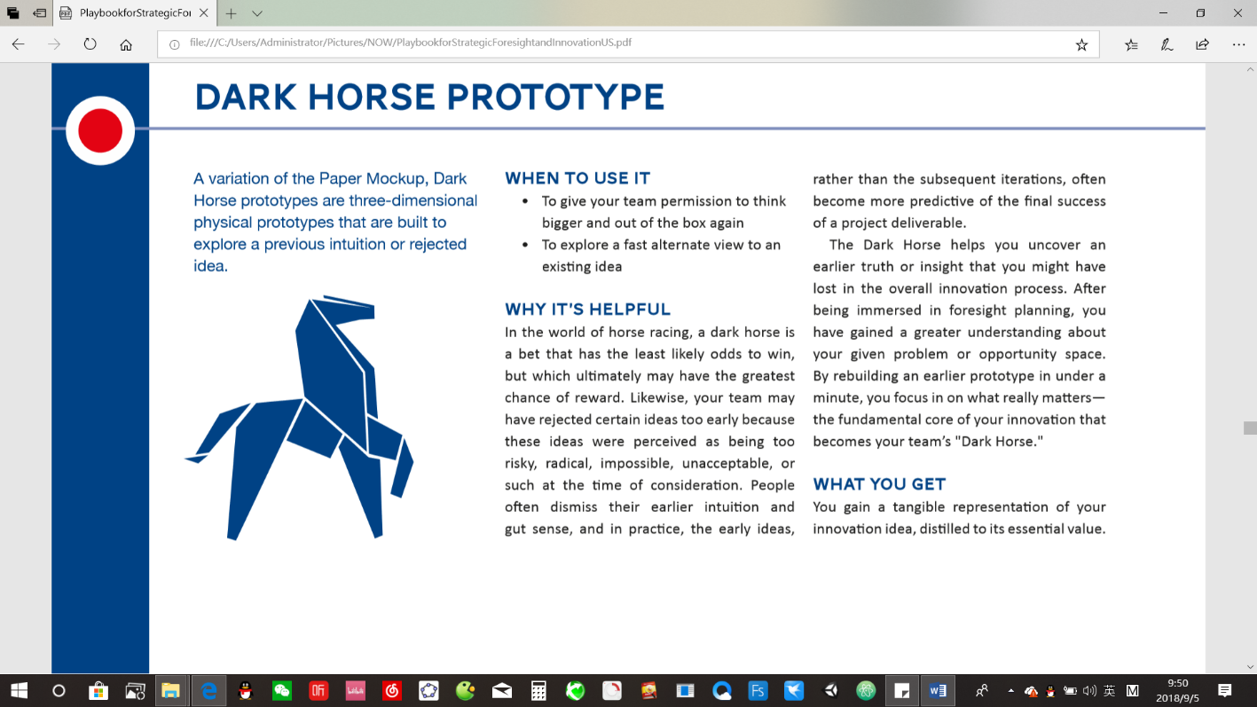

“The *Dark Horse Prototype* method was invented at Stanford University, and actually as a part of ME 310 courses. Probably about fifteen or so years ago, one of the professors observed that student teams were converging too quickly on an idea, and forgetting that they had learnt so much along the way and they also may have overlooked good ideas which they came up before and now they have the knowledge to evaluate these ideas. So, the *Dark Horse Prototype* asks you to consider what is your equivalent of the dark horse, what is the part of your idea that could come from behind. Now when you look at everything, it offers the best chance to win. At the time you thought it was too crazy, too risk, too impossible, but now with the latest understanding, you realize that maybe that’s something that could be the best idea of all.”

“Alright, now we ‘re going to continue the exercise that I gave you on Tuesday. So, I want you to find your partner again and the two of you pick one solution that you’ll mock up. We have supplies here and I want you to build it. Remember, its not meant to be perfect. You learn, explore during the experience.” She finished.

Previously, my partner shared her rough travelling experience when she was visiting Yosemite National Park. There was no air-conditioning on the bus; The seats were pretty vintage and uncomfortable; The trip to the mountain top was long and boring. Due to the limited time, after a short discussion, we quickly decided a solution and collected the materials needed for prototyping. Within two minutes, we finished our first prototype, but soon we realized there were some things we could improve and we modified our model for several rounds. As we went through the iteration, we truly learnt that it’s really a great way to communicate your ideas to others by showing them, instead of only talking to them, hoping they could figure out what’s in your head. When the time was up, each group showed and explained details about their mock-ups to the class, though some of us hadn’t finished them yet. Then Ms. Carleton asked us to use the *Dark Horse Prototype* method. “What I want you to do is to work on the other idea from your friend, to consider what might be the equivalent of the dark horse and see if you can prototype it.” She continued.

Given limited time, we were racking our minds to think of any moon-shot. Then I came up with the idea that maybe, we could build an anti-gravitational device to the vehicle and it provides the car with anti-gravitational force to enable it float above the floor. The device would adjust the strength level of the force according to your surroundings. With the device, you can drive across traffics, rivers, basically everything smoothly. So, we built the idea into our prototype, pitched it to Ms. Carleton and she seemed to like it pretty much.

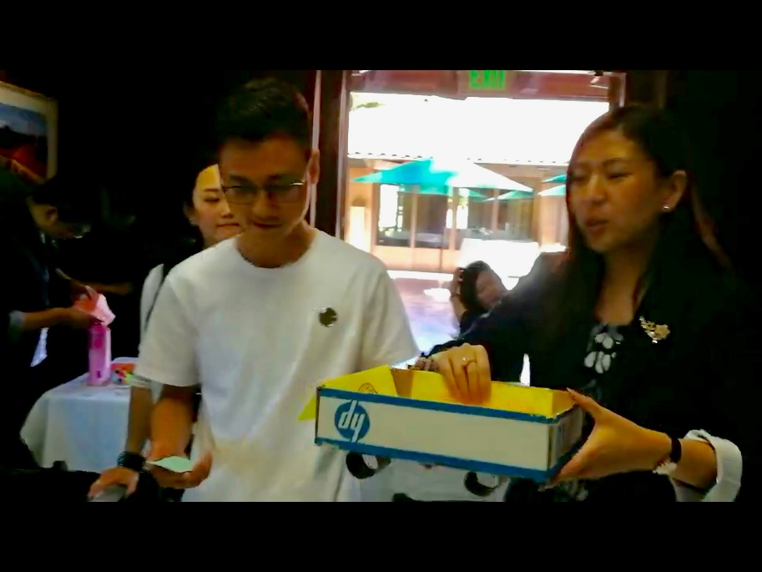





“So, the *Dark Horse Prototype* can be used to test what your users want and what you think they want. I definitely encourage you to use *Dark Horse Prototype* in other work and projects. Finally, I hope we can stay in touch with each other either by we-chat or other emails. Please consider me as part of your eco-system. Thank you all for being here! It’s been a great experience being with you guys!” She concluded.

After the class, we all went outside and took group picture together.

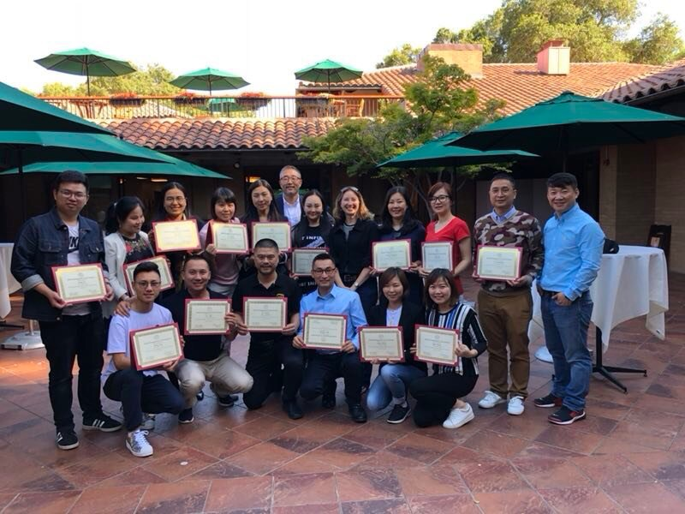

Your boy is over here

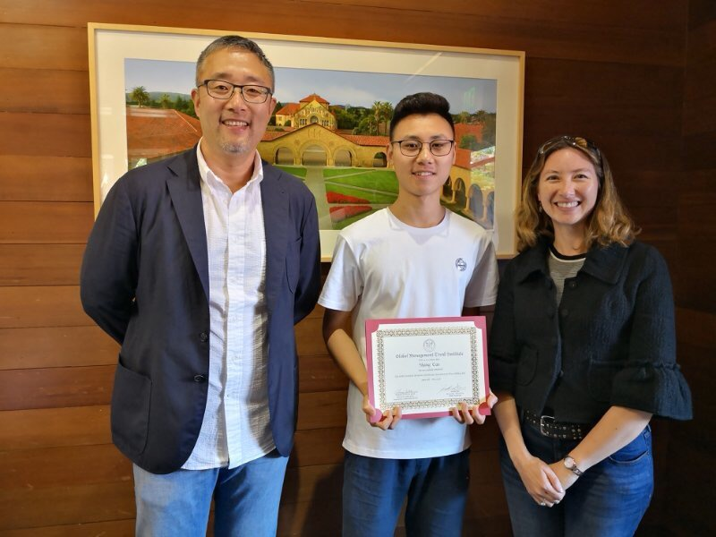 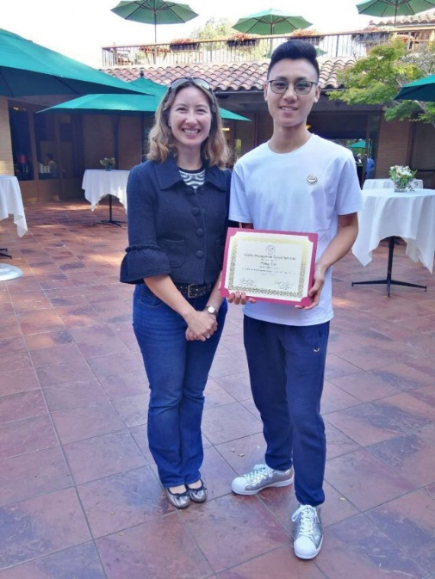

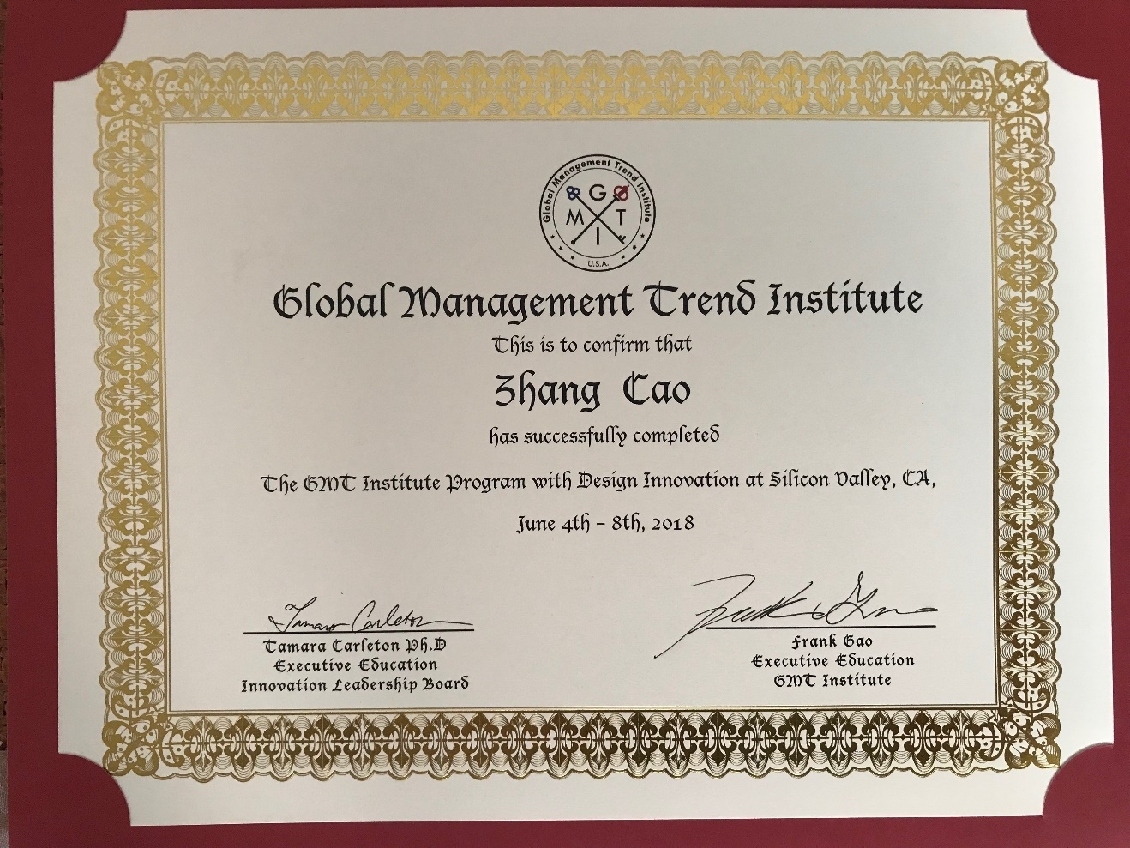

. . . More to be continued

in the future (maybe tomorrow; maybe the next second; maybe …)

Silicon Valley mentality: You learn by doing.

Ending: previously, my dad who attends the “*Strategic Innovation & Design Thinking*” class for entrepreneurs like himself at our local university came to me one day and asked me that if I was interested in such a twelve-day *Strategic Innovation & Design Thinking* tour to America. I had never heard of “Design & Innovation” such concept before and the only thing I knew was that it’s definitely for entrepreneurs that I was not. I asked him for more details but he was not given any more information on the trip until next week and the decision needed to be made by the end of this week. Anyway, I decided to give it a try, after all, I had never been to America and it’s not a bad thing to take a break from my regular busy studying schedule. Never had I expected that we were going to visit so many great companies in Silicon Valley nor to actually attend classes at Stanford. It turned out to be one of the trips I liked most and had so much impact on me, let me

know more about Silicon Valley and Stanford, help me find out where my passion lies in. Without take this chance, I wouldn’t have so many stories share with you about it and I’m glad that I made a good choice and I’ll always give it a try no matte